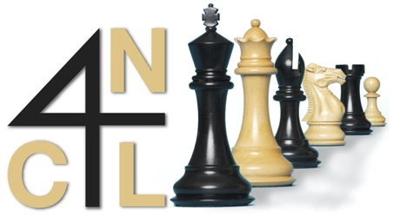 | FOUR  NATIONS  CHESS LEAGUE

4NCL Rapidplay 9th-10th October, report by Lawrence Cooper

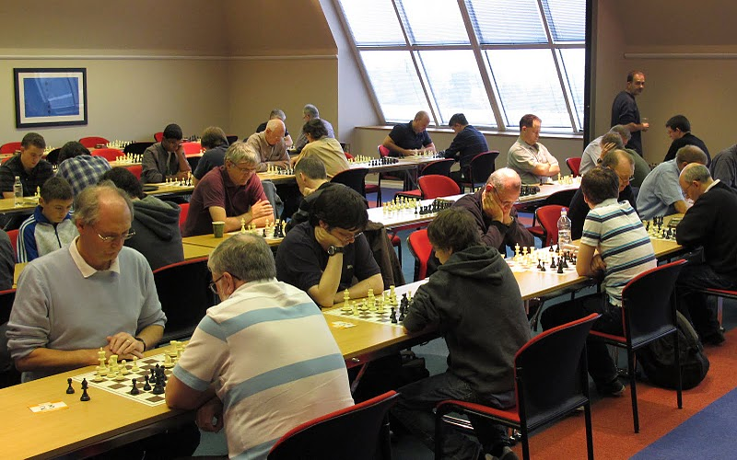
The third 4ncl team and second individual rapidplay took place at Harben House DeVere venue in Newport Pagnell last weekend. The team event had 27 teams and the individual had 74 players. The organisers generously agreed to allow any players playing in the team event to have free entry to the individual. The time limit was 10 minutes plus an increment of 5 seconds a move.
The main playing hall

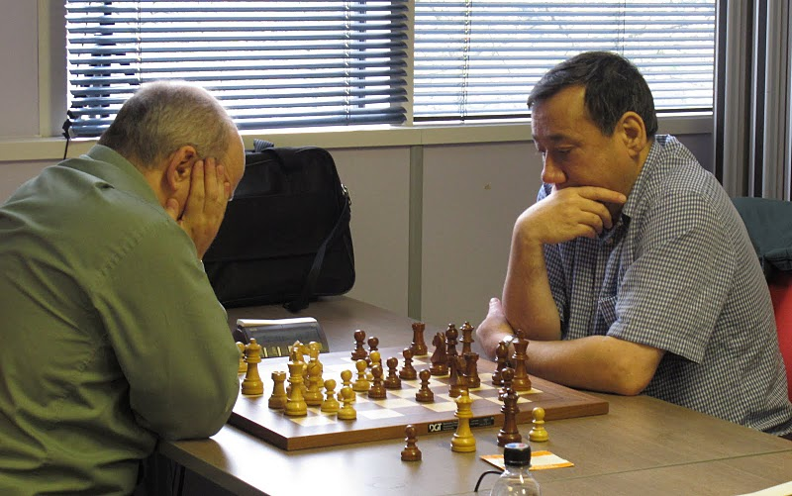
The top seeds in the team event were Pride & Prejudice comprising GMs Mark Hebden, Tony Kosten and Aaron Summerscale as well as IM Thomas Rendle. Second seeds were NACCPO 1 comprising GMs Gawain Jones and Keith Arkell, IM Lawrence Cooper and one of England’s most promising juniors, Brandon Clarke. After that there appeared plenty of talented teams including the Youth team of Yang-Fan Zhou, Callum Kilpatrick, Sam Franklin and Subin Sen as well as strong Barbican, Bristol and Cambridge University teams. Metropolitan Police also included GM William Watson in their team.

Congratulations to Barbican 1 who won the team event and defeated both their nearest rivals NACCPO 1 and Pride & Prejudice. Over the years, Barbican have often defeated teams rated well above them and this event proved no exception. Despite the late withdrawal of GM Jonathan Parker the team of John Cox, Matthew Piper, Peter Poobalasingam and Rafe Martyn finished a game point clear of the field despite trailing NACCPO by a game point going into the last round. Whilst Barbican had a convincing 4-0 victory NACCPO struggled to a 2-2 draw with Bristol and even this score flattered them. It was just enough for NACCPO to gain second place ahead of Pride & Prejudice though.

For those wondering what NACCPO stands for it is The National Alliance of Childhood Cancer Parent Organisations http://www.naccpo.org.uk/ . My association with them stems back to when I worked at RAF Stafford and one of my work colleagues had a son who became ill with leukaemia. Although he made a full recovery, I have kept links to the charity and although my fund raising days are virtually over now I still keep in contact and use the charity name where possible to give them some free publicity and hopefully increase their public profile (hence this shameless plug!).

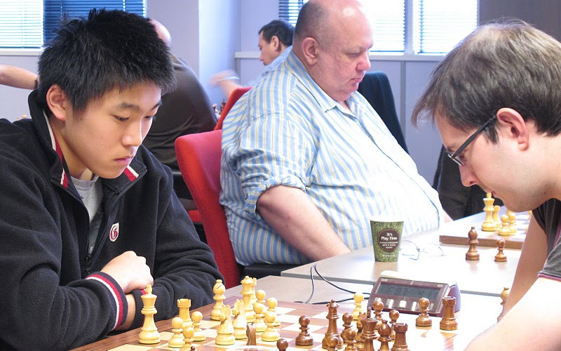
The highest individual scores in the team event were Matthew Piper of Barbican with an amazing 8.5/9, Victor Jones of RSI with 7.5/9 and the following players all scored 7, William Watson who represented Metropolitan Police, Keith Arkell & myself from NACCPO 1, Sue Maroroa from NACCPO’s U175 team, Aaron Summerscale of Pride & Prejudice and Yang-Fan Zhou of the Youth team.

Yang-Fan Zhou who also finished 3rd= in the individual event.

Team event:
1st Barbican 26.5
2nd NACCPO 25.5
3rd Pride & Prejudice 25.0
Best Junior Youth 19.5
Best U175 AMCA 19.5

You can see the full team cross-table here:
http://www.bcfservices.org.uk/livechess/4ncl/1011/rapid/index.htm#teampos

The individual event appeared to be between the three GMs Gawain Jones, Mark Hebden and Keith Arkell. As was the case in the team event, though, results didn’t run according to grading. Mark Hebden raced to 5/5 whilst Keith lost ground with a defeat to David Buckley in round 3 and Gawain started with 1.5/3. Mark then lost ground losing to Thomas Rendle in round 6 and Craig Pritchett in round 7. Thomas’s outright lead was short-lived though as defeat to Keith Arkell in round 7 left several players in the joint lead on 6/7. Keith defeated Craig whilst Tom defeated Yang-Fan to leave Keith & Tom joint leaders on 7/8 with Keith downfloating to Alexei Slavin with black and Tom facing James Sherwin with white. While early draw offers from the leaders were rejected Tom went on to win comfortably to reach 8 whilst Keith had a hard fought draw ending in perpetual leaving Keith on 7.5 and Alexei on 7 along with Mark Hebden and Yang-Fan Zhou.
Individual event:
1st Thomas Rendle 8.0/9
2nd Keith Arkell 7.5/9
3rd Mark Hebden 7.0/9
Yang-Fan Zhou
Alexei Slavin
Best Junior Yang-Fan Zhou 7.0/9
Best U175 Hubert Mossong 5.0/9

You can see the full individual cross-table here:
http://www.bcfservices.org.uk/livechess/4ncl/1011/rapid/indiv_crosstable.htm

Whilst I think the event has the potential to become very popular and successful it is clear that improvements can be made in future years. For example, having the matches split over two rooms with initially pairings only available in one room was a problem, but fortunately Claire Summerscale was kind enough to remedy this. I should point out that Claire Summerscale, Mike Truran, the captains and the arbiters did everything they could to limit the disruption and I am confident that the event will become an established and successful part of the tournament calendar, which I look forward to playing in again in the future.
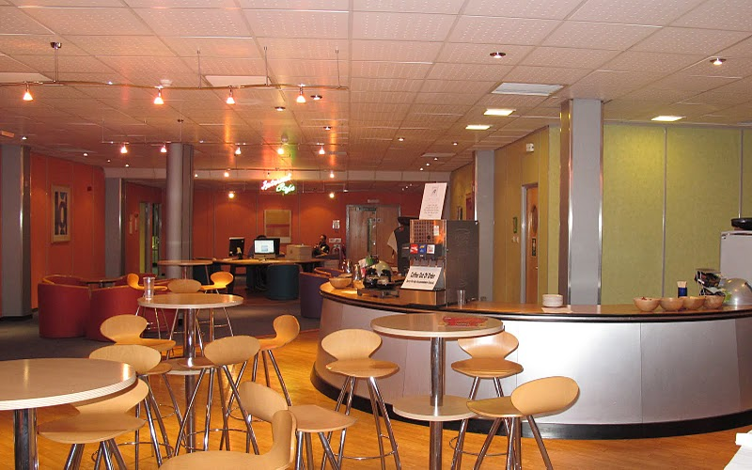
I should also mention that the live coverage of the top two matches was a welcome innovation and allowed those not at the venue to witness all the blunders, thrills and spills as they took place live. The venue and playing conditions were also good with several internet terminals available outside the room where the top three matches were accommodated.
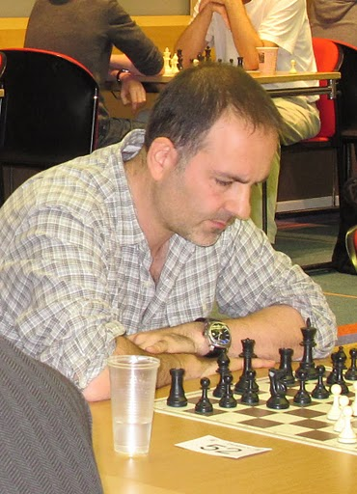
Nicholas Thomas of NACCPO 2, who mated with bishop and knight in the team event.

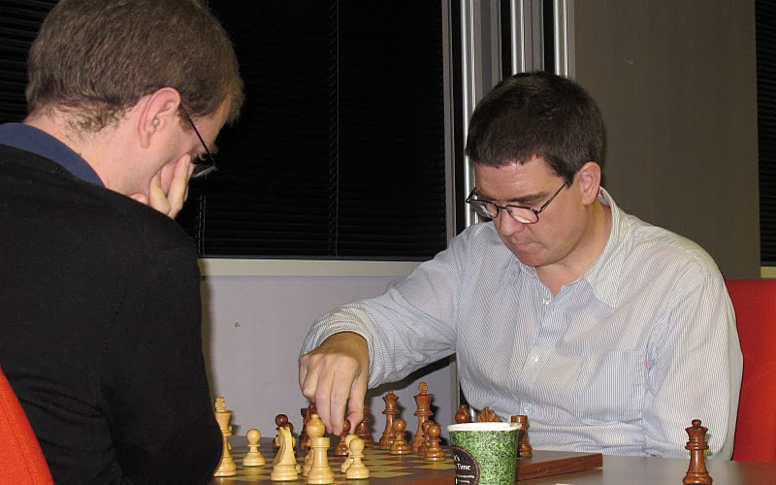

Matthew Piper who scored an amazing 8.5/9 faces GM William Watson.

